2014 ORIENTATION

NAME DATE

EXAMINER SCORE

MULTIPLE CHOICE – SELECT THE BEST ANSWER
- To be eligible for membership one must be:
  - a legal resident of the US or Canada.
  - able to legally possess firearms.
  - a member of the National Rifle Association.
  - all of the above.
- Live fire bays are open:
  - dawn to dusk.
  - according to the shooting facilities policy.
  - 9 am to sunset.
- Firearm types allowed on LGC ranges include:
  - any rifle or handgun up to .50 BMG.
  - anything you can safely shoot without help.
  - any legally possessed firearm, with some restrictions.
- Eye protection is required:
  - for anyone shooting.
  - for anyone observing someone else shoot.
  - for everyone on or near a live fire bay that is in use.
- Hearing protection is required:
  - when you are shooting.
  - when you are on a bay where someone else is shooting.
  - a and b.
- If you find trespassers, you should:
  - invite them to shoot with you.
  - quickly brief them on the rules and wish them luck.
  - ask them to leave, call the police if they don't, and file an incident report.
- Long guns should be carried:
  - muzzle pointed straight up.
  - unloaded and cased.
  - unloaded with the action open and muzzle pointing up or down.
  - b or c.
- Handguns should be carried:
  - in your pocket or other secure location.
  - unloaded in a holster or gun bag.
- A loaded rifle/shotgun may be placed in a rack:
  - with the safety on.
  - if you place a sign reading “LOADED” on the gun.
  - if you stay with it to make sure no one touches it.
  - never.
- Once a firing line has been established, you should go downrange only:
  - when all firearms are cleared and racked or holstered/cased.
  - when all ammunition has been expended or put away.
  - when everyone on the line has stopped shooting.
- As a club member, you may invite guests but:
  - you have to pay a fee for each guest.
  - you are responsible for them.
  - no more than three at a time.
  - all of the above.
- Guests may use club facilities unsupervised:
  - if they are certified range officers.
  - if they are law enforcement or active duty military personnel.
  - if you check on them at least once an hour.
  - never.
- Guests must use eye and ear protection:
  - only if they are going to shoot.
  - whenever they or anyone on the bay are going to shoot.
- The Baffles are intended to:
  - offer shade and protection from falling trees.
  - provide a place to hang targets.
  - prevent a stray round from leaving the range.
- When shooting on a bay with baffles, you must position yourself:
  - where you can not see ‘Blue Sky’.
  - so bullets pass under the baffles.
  - so a stray shot can not leave the bay.

- Bays set up for a match may be used for practice:
  - when the setup crew is done.
  - with the match director's permission.
- LGC policies and other official documents are:
  - classified, burn before reading.
  - open to the public.
  - for the use of LGC members.
- On meeting day, when meeting time rolls around, you should:
  - keep shooting, so long as it is a quiet load.
  - stop shooting and attend the meeting.
  - a or b
- The main gate and club facilities:
  - may be left open while you are there.
  - must be secured, except during official functions like matches and meetings.
- If you discover a building inspector or other government official on the club property, you should:
  - call the police and have him ejected.
  - call the township and complain.
  - provide escort, note everything he does, and fill out an incident report after he leaves.

TRUE/FALSE
- T F A member can challenge anyone on club property to prove their membership.
- T F Shooting glass bottles and old televisions is OK if you clean up afterward.
- T F Pets and children must be under your direct supervision at all times.
- T F The Safe Areas are for loading magazines and test firing.
- T F LGC Ranges are ‘cold’, except during official, supervised events.
- T F Poppers and plates are made of armor plate that can take a hit from most rifles.
- T F Any berm large enough to stop a bullet is an appropriate backstop.
- T F It’s OK for rounds to hit the range floor so long as they don’t leave the range.
- T F Targets placed in front of a backstop can be at any height.
- T F The LGC calendar shows when ranges will be used for setup/matches.

ESSAY / SHORT ANSWER
- ____________ discipline is the practice of maintaining a safe muzzle direction at all times.
- ____________ discipline is the practice of staying away from the trigger until on target and ready to fire.
- Be sure of your ________________ and what is behind/around it.
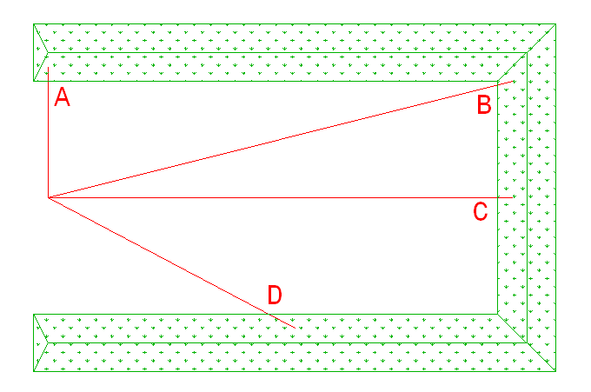
In the diagram above:
- Shooting in direction ____ or ____ is acceptable for informal practice.
- Shooting in direction ____ would only be permitted during supervised events.
- Shooting in direction ____ is never allowed.
- The visual aids on bay 3 are there to assist with placement of ______________ and __________.
- The striped side of the rotary range flags at LGC indicate a range is ______ and the solid (green) side indicates a range is __________.

